# SPRINT - 1

|  |  |
| --- | --- |
| Date | 29 October 2022 |
| Team ID | PNT2022TMID43251 |
| Project | Smart Waste Management system  for metropolitan cities |

**OBJECTIVE:**

A 24×7 monitoring system is designed for monitoring dumpsters. The ultrasonic sensor is used for measuring the level of waste in the dustbin. The DC motor powered platform is used for segregating wet and dry waste. The IR sensor and moisture sensor is used for separating wet and dry waste. If either of the containers is full then an alert message is sent from the dustbin to garbage collector and the cloud. In turn, based on the allotment garbage collector can clear the corresponding dumpster.

# CODE FOR REGISTRATION AND LOGIN CREDENTIALS:

## Code.gs:

function doGet(e) {

var x = HtmlService.createTemplateFromFile("Index");var y = x.evaluate();

var z = y.setXFrameOptionsMode(HtmlService.XFrameOptionsMode.ALLOWALL);return z;

}

function checkLogin(username, password) {

var url = 'https://docs.google.com/spreadsheets/d/1Vi3NN00OANInpp5AYlXcr7_xabLCZWCFxMTCU9YTsCs/edit#gid=0'; var ss= SpreadsheetApp.openByUrl(url);

var webAppSheet = ss.getSheetByName("DATA");var getLastRow = webAppSheet.getLastRow(); var found_record = '';

for(var i = 1; i <= getLastRow; i++)

{

if(webAppSheet.getRange(i, 1).getValue().toUpperCase() == username.toUpperCase() && webAppSheet.getRange(i, 2).getValue().toUpperCase() == password.toUpperCase())

{

found_record = 'TRUE';

}

}

if(found_record == '')

{

found_record = 'FALSE';

}

return found_record;

}

function AddRecord(usernamee, passwordd, email, phone) {

var url = 'https://docs.google.com/spreadsheets/d/1Vi3NN00OANInpp5AYlXcr7_xabLCZWCFxMTCU9YTsCs/edit#gid=0'; var ss= SpreadsheetApp.openByUrl(url);

var webAppSheet = ss.getSheetByName("DATA"); webAppSheet.appendRow([usernamee,passwordd,email,phone]);

}

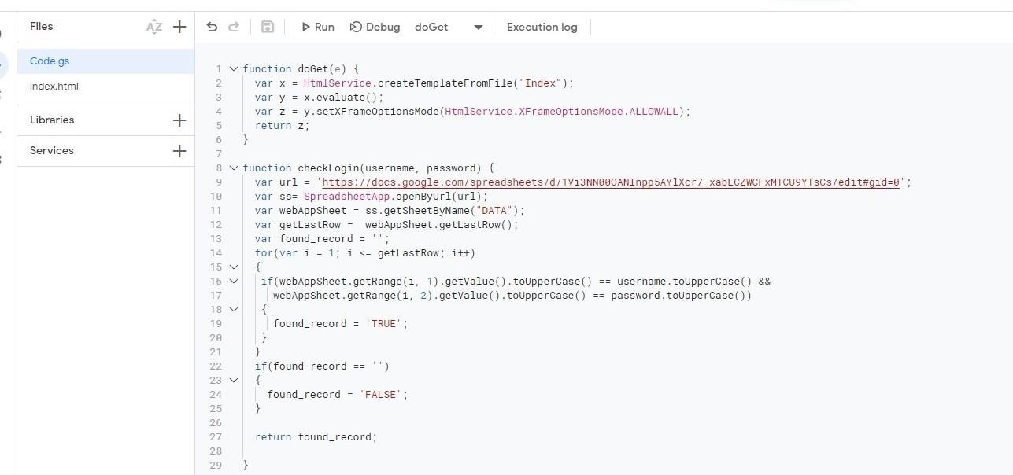

## index.html:

<!DOCTYPE html>

<html>

<head>

<style>

body{

background-image:url('background.jpg');background- repeat: no-repeat; background-attachment: fixed; background-size:100% 100%;

}

</style>

<base target="_top">

<script>

function AddRow()

{

var usernamee = document.getElementById("usernamee").value; var passwordd

= document.getElementById("passwordd").value; var email = document.getElementById("email").value;

var phone = document.getElementById("phone").value;

if (usernamee==""|| passwordd==""|| email==""|| phone=="") {return false;

}

else { google.script.run.AddRecord(usernamee,passwordd,email,phone);

document.getElementById("page2_id1").className = "page2_id1-off"; document.getElementById("page3_id1").className = "page3_id1";

}

}

function LoginUser()

{

var username = document.getElementById("username").value;var password = document.getElementById("password").value; google.script.run.withSuccessHandler(function(output)

{

if(output == 'TRUE')

{

var url1 ='https://node-red-jrfhu-2022-10-06.eu- gb.mybluemix.net/ui/#!/0?socketid=kVaDwxl44Sp25mOZAAAX';

var winRef = window.open(url1);

winRef ? google.script.host.close() : window.onload=function(){document.getElementById('url').href = url1;}

}

else if(output == 'FALSE')

{

document.getElementById("errorMessage").innerHTML = "Invalid data";

}

}).checkLogin(username, password);

}

function function1(){

document.getElementById("page1_id1").className = "page1_class1-off"; document.getElementById("page2_id1").className = "page2_id1";

}

function function3(){ document.getElementById("page3_id1").className = "page3_id1- off";document.getElementById("page1_id1").className = "page1_id1";

}

</script>

<style>

/*page1*/

.page1_class1-off{ display: none;

}

/*page2*/

.page2_class1{ display: none;

}

.page2_id1-off{

display:none;

}

/*page3*/

.page3_class1{

display:none;

}

.page3_id1-off{

display:none;

}

input[type=text]:hover{

border-bottom:2px solid black;

}

input[type=number]:hover{

border-bottom:2px solid black;

}

input[type=password]:hover{

border-bottom:2px solid black;

}

</style>

<meta name="viewport" content="width=device-width, initial-scale=1.0">

</head>

<body>

<br><br>

<!--page1-->

<center>

<div class="page1_class1" id="page1_id1" style="background-

color:rgb(135, 207, 235);border:2px solid gray;border-radius: 20px;width: 250px;padding-top: 10px;padding-bottom: 20px;padding-left: 20px;padding-right: 20px;">

<h1>Login Here</h1>

<br>

<p>Username</p>

<input type="text" id="username" placeholder=" Enter Username" style=";outline: none; text-align: center;font-size:0.9em

;width: 50%;font-weight:bold;"/><br>

<br>

<p>Password</p>

<input type="password" id="password" placeholder=" Enter Password" style="border- top: none;border-right: none;border-left: none;outline: none; text-align: center;font-size:0.9em ;width: 50%;font-weight:bold;"/>

<br><span id="errorMessage" style="color: red" ></span><br>

<br>

<input type="submit" value="Login" onclick="LoginUser()" style="float: centre;padding-top: 1px;padding-bottom: 1px;padding-left: 10px;padding-right: 10px;font-size: 0.9em;font- weight:bold;" /><br>

<br><br>

<b>If you don't have an account,</b><input type="button" onClick="function1()" value="Create New" style="margin-top: 5px;font-weight:bold;" />

</div>

<!--page2-->

<div class="page2_class1" id="page2_id1" style="background-

color:rgb(135, 207, 235);border:2px solid gray;border-radius: 20px;width: 250px;padding-top: 10px;padding-bottom: 20px;padding-left: 20px;padding-right: 20px;">

<h1>Register Here</h1>

<p>Name</p>

<input type="text" id="usernamee" placeholder=" Enter Name" style="border-top: none;border-right: none;border-left: none;outline: none; text-align: center;font-

size:0.9em ;width: 50%;font-weight:bold;"/><br>

<br>

<p>Password</p>

<input type="password" id="passwordd" placeholder="Create password" style="border-top: none;border-right: none;border-left: none;outline: none; text-align: center;font-size: 0.9;width: 50%;font-weight:bold;" /><br>

<br>

<p>Email</p>

<input type="text" id="email" placeholder=" Enter Email" style="border-top: none;border-right: none;border-left: none;outline: none; text-align: center;font-

size:0.9em ;width: 50%;font-weight:bold;"/><br>

<br>

<p>Phone Number</p>

<input type="number" id="phone" placeholder="Enter number" style="border-top: none;border-right: none;border-left: none;outline: none; text-align: center;font-

size:0.9em ;width: 50%;font-weight:bold;" /><br><br>

<br><br>

<input type="submit" value="Create" onclick="AddRow()" style="float: centre;padding- top: 1px;padding-bottom: 1px;padding-left: 10px;padding-right: 10px;font-size: 0.9em;font-weight:bold;" />

<br>

</div>

<!--page3-->

<div class="page3_class1" id="page3_id1" style="background:none;border:2px solid gray;border-radius: 20px;width: 250px;padding-top: 10px;padding-bottom: 20px;padding-left: 20px;padding- right: 20px;"><center>

<h2> REGISTRATION SUCCESSFUL! Login to your account</h2>

<input type="submit" onClick="function3()" value="Login" style="font-weight:bold;"><br>

</div>

</center>

</body>

</html>

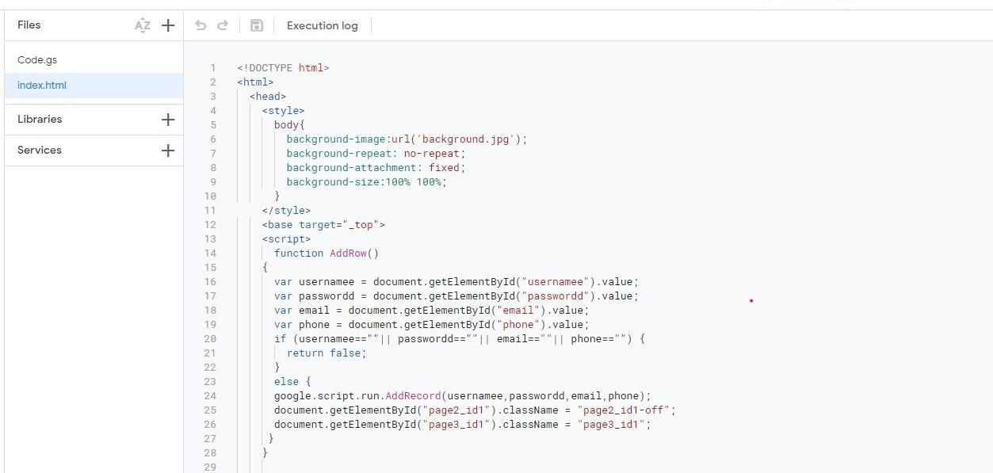

# CIRCUIT DIAGRAM:

